1. **DEFINING THE PROJECT**

This project provides a computer vision-based fire detection and hazardous fire recognition technique by processing the video data generated by the ordinary camera. The suggested technique uses fire color and fluctuation characteristics to detect it.

Initially, the algorithm locates the regions of the video where there is motion from these regions, fire-colored pixels are collected and then wavelet transformation is used to ensure that the moving object is fire. Experimental findings show that the proposed technique is effective in detecting and classifying fire as hazardous or controlled.

Objectives

* To detect fire by using the computer vision technology that will alert people by early detection of fire.
* To protect human lives, material assets and the environment from the dangers and the effect of fire.
* To detect fire with a different approach rather than using an existing system.

1. **PLANNING THE PROJECT**

Work Breakdown Structure

Risk Identification Chart

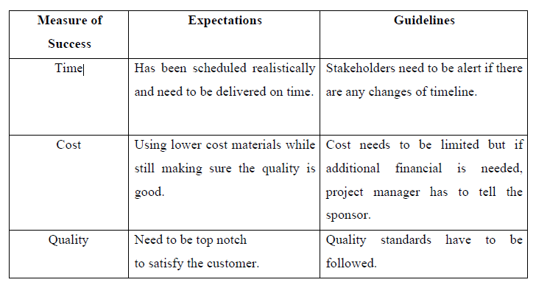

Responsibility Assignment Matrices (RAM)

Project Manager - Kaw Ji Zian

A project manager is someone who has the overall responsibility for initiating, planning, designing, carrying out, monitoring, controlling, and successfully closing a project.

The project manager will organize the project calendar for the stakeholders, make sure that each step is carried out, conduct budget planning, and process control, and troubleshoot any issues that arise. The project manager needs to possess more general managerial abilities as well as the capacity to ask widespread questions, recognize unintentional assumptions, and settle conflicts.

System Designer - Md Fawzul Kabir Badhan

The system designer's job is to create a detailed blueprint and instructions that the programmers can follow. The specification of specifications that the system or business analyst has developed is the primary input document used by the system designer.

To guarantee that the system is thoroughly tested, the system designer must also create test schedules and collaborate with a group of users and system testers.

Programmer - Yusuf Athallah Adriyansyah

A coevolutionary neural network has been used to construct an algorithm and a system, and the duty of the programmer is to define, develop, install, and test a software framework that uses it. The software can be updated and maintained to make sure that security flaws are fixed and that it works with new databases once the final development environment has been given to the programmer.

On a computer or smartphone, programmers will create features that let users carry out basic operations, while other programmers will create the underpinning systems that manage networks.

**Project Planning Summary**

**Modules and Components**

**Budget**

1. **IMPLEMENTING THE PROJECT PLAN**

**Deliverables**

* Successfully detecting the Fired-Colored Pixels.
* Fire detection algorithm.
* Final report of the system.

**TASK AND ESTIMATED COST**

**MILESTONE CHART**

